**Challenges and Strategies in Group Discussion Dynamics**

*Submitted in partial fulfillment of the requirements of the Course on*

*English For Engineers – II (BTBS-T-HS-201)*

*of*

**Bachelor of Technology(B.Tech)**

**Biju Patnaik University of Technology**

**Department of Basic Science and Humanities**

**Gandhi Institute For Technology (GIFT), Bhubaneswar**

|  |  |  |  |
| --- | --- | --- | --- |
| **Name of the Student** | **Registration No** | **Semester** | **Branch** |
| **Hrishita Rout** | **2301298401** | **2nd** | **CSE** |
| **Monalisa Sahoo** | **2301298172** | **2nd** | **CSE (AI)** |

**Ms Pranati Mishra Ms Pranati Mishra**

**Name of the Guide Head of the Dept. BS&H**

### Acknowledgement

We would want to convey our heartfelt gratitude to Assistant Professor Pranati Mishra, for her invaluable advice and assistance in completing the project. She was there to assist us every step of the way, and her motivation is what enabled us to accomplish the task effectively. We would like to thank our Principal Dr S.K. Maharana and mentor Dr Khalid Khan, who helped me learn a lot about this project. His ideas and comments aided in the completion of this project.

**Hrishita Rout (2301298401) Monalisa Sahoo (2301298172)**

**Certificate**

This is to certify that the Subject Specific Project entitled “Library Management System” has been carried out by 1. Hrishita Rout (2301298401) & 2. Monalisa Sahoo (2301298172) and completed under my guidance and the project meets the academic requirement of the subject English for Engineers - II (BTBS-T-HS-201).

**Signature of the guide Signature of Supervisor**

**Table of Contents**

|  |  |  |
| --- | --- | --- |
| Sr. No | Contents | Page No |
| 1 | Title | 1 |
| 2 | Acknowledgement | 2 |
| 3 | Certificate | 3 |
| 4 | Abstract | 5 |
| 5 | Introduction | 6 |
| 6 | Literature Survey | 7 |
| 7 | Problem Statement | 9 |
| 8 | Method | 10 |
| 9 | Result and Discussion | 11 |
| 10 | Conclusion | 15 |
| 11 | References | 16 |

**Abstract**

The aim of this research is to explore about the tricky dynamics of group discussions. Through a complete evaluation we will determine the various challenges and strategies to overcome in group discussions. This study highlights the various complexities in the collaboration and helps us to deeply acknowledge the significance of member participation and collegiality. The proposed techniques embody fostering open conversation, organising clean roles, and leveraging numerous strengths inside the institution. By knowledge and addressing those demanding situations, this looks at offers treasured insights for people and facilitators in search of to decorate the effectiveness of institution discussions throughout diverse contexts.

**Keywords:** Group Discussions, Dynamics, Challenges, Strategies, Participation

**Introduction**

The term “group dynamics” refers to the interactions between people who are together in a group setting. It can be studied in business settings, in volunteer settings, in social or classroom settings. Any time there are three or more individuals together interacting or taking together, there are group discussion dynamics. Group roles are largely determined by a combination of a person’s personality and his or her experience with group settings. In other trems it means that we have been administered a topic and we are supposed to come out with a common conclusion. On break through we define Challenges in group discussions can serve various purposes. They can stimulate critical thinking, offer alternative perspectives, foster creativity, and ultimately lead to better decision-making. However, they can also disrupt harmony and hinder progress if not managed constructively. Balancing assertiveness with respect for others' viewpoints is key in navigating these dynamics effectively. Then In group discussion dynamics, "strategies" refer to the plans or approaches participants use to achieve their goals within the discussion. These strategies can include tactics for expressing opinions, persuading others, managing conflicts, or guiding the direction of the conversation towards certain outcomes.

**Literature Survey**

Group Discussion Dynamics: This article explores the key elements of communication processes within the group discussions, including interaction patterns, decision making dynamics and the major role of leadership. It is about understanding the communication process. [Dennis Gouran, Marshall Scott Poole, Small Group Behavior, 1989]

Modeling group discussion dynamics: This paper presents a formal model of group discussion dynamics, revealing that understanding face-to-face communication in group discussions can provide insights into human collaboration, facilitate brainstorming sessions. It also suggests that meeting dynamics can follow similar patterns across languages and topics, and predict meeting outcomes. [Wen Dong, Ankur Mani, Alex Pentland, Bruno Lepri, Fabio Pianesi, IEEE Trans. Auton. Mental Dev, 2011]

Opportunities lost, challenges met: The study explores the application of group dynamics in writing projects, focusing on MBA students’ business experience or complex cases. Students receive instruction in problem-solving techniques and group dynamics. Evaluations show that the groups complete tasks efficiently. [Judith Bogert, David Butt, The Bulletin of the Association for Business Communication,1990]

Understanding the dynamics of motivation in socially shared learning: This study explores motivation dynamics in socially shared learning among higher education students using quantitative and qualitative methods. It investigates individualmotivations and task-specific goals, and how they combine as a group. [Sanna Järvelä, Hanna Järvenoja, Marjaana Veermans, International Journal of Educational Research 47 (2),2008]

Classroom participation and discussion effectiveness: Student-generated strategies-The study examines the effectiveness of classroom discussion in graduate business classes, focusing on student-generated strategies. The results show that factors that enhance participation quality and discussion effectiveness include required participation, incorporating ideas and experiences, active facilitation, asking effective questions, creating a supportive environment, and affirming contributions. [Elise J Dallimore, Julie H Hertenstein, Marjorie B Platt, Communication Education 53 (1), 2004]

Understanding Group Discussions and Systems: This article provides an overview of group dynamics theory and its applications in various settings, including families, organizations and theory groups. It discusses key concepts such as roles, norms, cohesion and concflict resolution strategies. [Joshua M. Liss, The Family Journal, 2012]

Group Discussion Dynamics In Focus Groups: This articles reviews the literature on group discussion dynamics in focus group research, examining factors influencing participant behaviour, interaction patterns and moderator strategies. [Farzana M. Moon and Philip J. Kitchen, International Journal of Market Research, 2017]

**Problem Statement**

Despite the recognized importance behind the group discussions, challenges exist in understanding its full potential. This section specifies the issues such as not taking turns because of lack of knowledge, skipped the chance, afraid of being not up to the mark and lack of confidence because of dominant people. There are several strategies to overcome these issues.

**Method**

The method used here is experimental to collect the information for analysis and discussion. Effective group discussions are crucial in both academic and professional settings. However, these discussions often encounter challenges such as communication barriers, uneven participation, and decision-making conflicts. This project aims to identify these challenges and develop strategies to address them, leveraging technology, peer conversations, and AI tools. In order to move further we need to identify the challenges and the very first step involves understanding the common issues that hinder the productive group discussions. This is achieved by examining the existing research to identify typical problems like dominance of certain members, lack of engagement from others, and difficulties in reaching consensus. Conducting surveys and interviews with classmates to collect firsthand accounts of their experiences and the specific challenges they face during group discussions. Strategies to overcome more typically involves fostering open communication, promoting equal participation, establishing clear goals and roles, building trust among group members and utilizing facilitation techniques. In a group discussion for those who are clueless we come up with 3 generating ideas technique to encourage them. This Technique involves three approaches to generate ideas such as KWA (Keyword Approach), VEP (View point of affected parties), SPELT (Social-cultural, political, economic, legal and technology to the given topic). Interaction despite an introvert-type personality is important. We figured out that listening is very crucial in all the aspects so if you have no knowledge then some participants refer to three approach scheme and try to make valuable points and show some participation. Another factor is leadership, the main work is to get the team on the track when they are off, keeping up the behavior of the team and managing the dominant participants.

**Result and Discussion**

The resultant is based upon the method of this project. While conducting a Group Discussion (GD) we saw many people with different personalities along with their view points and reflecting behavior. As we discussed earlier that dominance is the very first obstacle here so in order to overcome that we would need someone with great leadership, team spirit. The dominant speaks loudly over others, in a group discussion, no one is made leader. His/her own ability makes them a leader. Here the leader guides the way and observes every team member. His/her work stands with equality. Whenever someone is being dominant over others and not letting them speak their points as per the turns then the leader prompts and asks to let the others speak. As in a GD, everyone is free to speak anything related to the topic. Secondly, lack of focus is negative. Some people to prefer their points and do not listen the rest which further leads to confusion. Being attentive in order speak out is important and for that it requires attention at all costs.

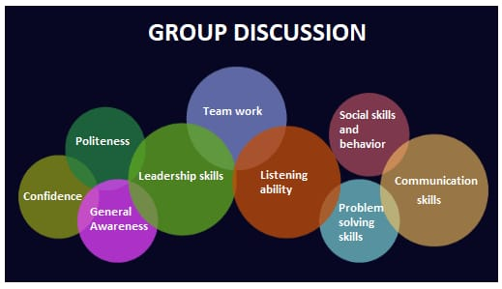

[Fig 1- This depicts the skills requirement in a group discussion]

Another technique is three approaches to generate ideas for those participants who do not have ideas related to the topic and can be seen in the category of unequal participation. The "Keyword Approach" (KWA) in a group discussion involves identifying key terms or phrases related to the topic and using them as focal points for discussion. Participants can take turns elaborating on these keywords, exploring their implications, and connecting them to broader themes or ideas. This approach helps maintain focus and ensures that the discussion remains relevant to the central topic. Secondly, integrating social-cultural, political, economic, legal, and technological (SPELT) perspectives into a group discussion can enrich the understanding and analysis of any topic. Further, in a group discussion, each affected party typically has their own viewpoint based on their interests, experiences, and beliefs. It's important to consider perspectives from all sides to reach a balanced understanding and potential resolution (VEP).

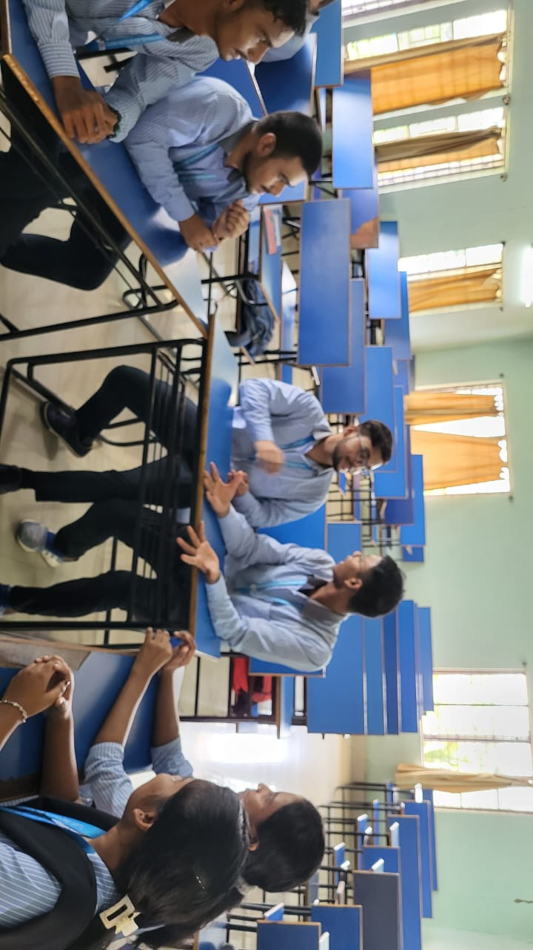

[Fig 2- This picture is from a live group discussion scene]

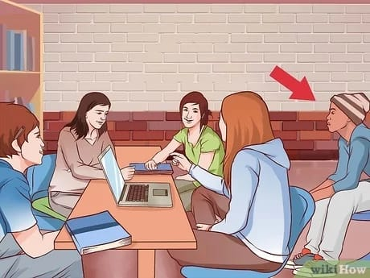

**[**Fig 2- The person on target is not taking turns because of fear**]**



[ Fig 3- This shows that the person is active but has no knowledge regarding the topic]

**KWA, VEP, SPELT
**

KWA, VEP AND SPELT 💡

[Fig 4- This is a picture of 3 approach technique]

**Conclusion**

In conclusion, we observed that either it can a reward or can be challenging in a group discussion. A group discussion can never run smoothly and be fruitful. We got to know group discussions can be dynamic in nature. In real life also we face many such challenges. In a Group Discussion, we got to know about challenging things like some being dominant, being shy and not being open up to anyone and letting go of their chances to speak. With respect to that, we have strategies as well like leadership, approaching scheme, fostering open communication, active listening and staying focused throughout the group discussion to make it an effective and successful one. By this, we build confidence, ability to think and understand. Group Discussion helps to inherit your inner potential skills.

**References**

1. <https://scholar.google.com/scholar?hl=en&as_sdt=0%2C5&q=challenges+and+strategies+in+group+discussion+dynamics+&btnG=#d=gs_qabs&t=1716274884593&u=%23p%3DPvMYI1kakewJ>
2. <https://journals.sagepub.com/doi/pdf/10.1177/108056999005300210>
3. <https://www.sciencedirect.com/science/article/pii/S088303550800030X>
4. <https://www.tandfonline.com/doi/abs/10.1080/0363452032000135805>
5. <https://youtu.be/2P3Nb9UB7PI?si=Oy48vyuvYU_wd-eK>
6. <https://youtu.be/RNvAOrEIM8c?si=r9InfX0fuzj98oYQ>